Tavor ULC/Tavor TD
CT-Hall Software Downloader Introduction for User
IMEI & MEP Generator User Guide
v0.33

FOR <CUSTOMER> USE ONLY
Not Approved by Document Control.
For Review Only.
MARVELL INTERNAL USE ONLY
DO NOT DISTRIBUTE

Document Conventions
 | Note: Provides related information or information of special importance.
 | Caution: Indicates potential damage to hardware or software, or loss of data.
 | Warning: Indicates a risk of personal injury.
Document Status
Doc Status: Introduction of CT-Hall IMEI & MEP Generator |  | Technical Publication: v0.3
This document is based on Qianqi Zhai.

For more information, visit our website at: www.marvell.com
Disclaimer
No part of this document may be reproduced or transmitted in any form or by any means, electronic or mechanical, including photocopying and recording, for any purpose, without the express written permission of Marvell. Marvell retains the right to make changes to this document at any time, without notice. Marvell makes no warranty of any kind, expressed or implied, with regard to any information contained in this document, including, but not limited to, the implied warranties of merchantability or fitness for any particular purpose. Further, Marvell does not warrant the accuracy or completeness of the information, text, graphics, or other items contained within this document.
Marvell products are not designed for use in life-support equipment or applications that would cause a life-threatening situation if any such products failed. Do not use Marvell products in these types of equipment or applications.
With respect to the products described herein, the user or recipient, in the absence of appropriate U.S. government authorization, agrees:
1) Not to re-export or release any such information consisting of technology, software or source code controlled for national security reasons by the U.S. Export Control Regulations ("EAR"), to a national of EAR Country Groups D:1 or E:2;
2) Not to export the direct product of such technology or such software, to EAR Country Groups D:1 or E:2, if such technology or software and direct products thereof are controlled for national security reasons by the EAR; and,
3) In the case of technology controlled for national security reasons under the EAR where the direct product of the technology is a complete plant or component of a plant, not to export to EAR Country Groups D:1 or E:2 the direct product of the plant or major component thereof, if such direct product is controlled for national security reasons by the EAR, or is subject to controls under the U.S. Munitions List ("USML").
At all times hereunder, the recipient of any such information agrees that they shall be deemed to have manually signed this document in connection with their receipt of any such information.
Copyright © 2026. Marvell International Ltd. All rights reserved. Marvell, the Marvell logo, Moving Forward Faster, Alaska, Fastwriter, Datacom Systems on Silicon, Libertas, Link Street, NetGX, PHYAdvantage, Prestera, Raising The Technology Bar, The Technology Within, Virtual Cable Tester, and Yukon are registered trademarks of Marvell. Ants, AnyVoltage, Discovery, DSP Switcher, Feroceon, GalNet, GalTis, Horizon, Marvell Makes It All Possible, UniMAC, and VCT are trademarks of Marvell. Intel XScale is a trademark or registered trademark of Intel Corporation or its subsidiaries in the United States and other countries. All other trademarks are the property of their respective owners.

Table of Contents
1 About This Document 4
1.1 Purpose 4
1.2 Abbreviations and Acronyms 4
2 Overview 5
3 IMEI File 6
4 MEP File 13
5 Producing a Log Table 18
6 Appendix 20
6.1 Report issues 20
6.2 Update this document 20
6.3 Revision History 21

About This Document

Purpose
The purpose of this document is to introduce IMEI Generator of Marvell CT-Hall Software Downloader.

Abbreviations and Acronyms
Table 1.1: Abbreviations and Acronyms
Acronym | Description
IMEI | International Mobile Equipment Identity
MEP | Mobile Equipment Personalization
SWD | Software Downloader
Tavor | Marvell cellular processor family
Tavor TD | Marvell Tavor chip for TD-SCDMA
TTC | Tiny Tiny Chip, also named Tavor ULC
UE | User Equipment, mainly Tavor Cellular Phone.
ULC | Ultra Low Cost

Overview

- IMEI is a file that contains a unique number of a target board and must be burned onto the target device in the production line process.
- MEP is a file has data such as the Networks allowed (Orange, Cellcom…), the Access Technology, the SIM number, etc.
- The IMEI &MEP Generator tool generates the IMEI and MEP files that are burned on target device.

IMEI File
Figure 3.1: IMEI and MEP Generator Main Window IMEI Tab
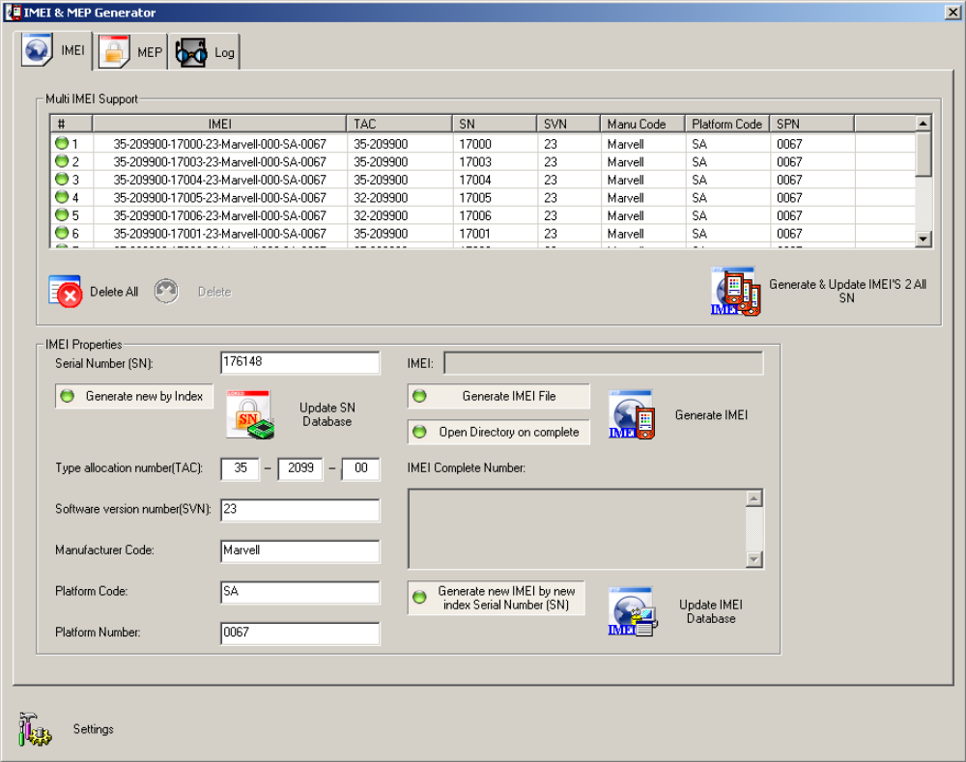

Table 3.1: IMEI File Fields
Field | Table Field | Description
Multi UE Support
 | IMEI | A unique number of a cellular phone
 | TAC | Type Allocation Number
 | SN | Serial Number
 | SVN | Software Version Number
 | Manual Code | Manufacturer's Code(such as "Marvell")
 | Platform Code | Platform Code such as "SA" for SAAR of  "EVB" for Evaluation Board.
 | SPN | Platform number
Delete All Button |  | Deletes all the IMEI from list and from DB
Delete Button |  | Deletes only the selected IMEI from list and DB
Generate & Update IMEIs 2 All Button |  | Generates the IMEI files and updates the DB to all items in the list
IMEI Properties
Serial Number |  | The board serial number
IMEI |  | Unique number of the cellular phone
Generate by new Index |  | Selecting this option generates a new SN  (adds 1 to the previous SN) after creating an IMEI file
Update SN Database button |  | Updates the DB with the new data entered
Generate IMEI File |  | If this option is not checked - the IMEI file will not be generated (even if the Generate IMEI button is clicked)
Open Directory on complete |  | Opens the directory where the IMEI file is  Created after the file is created.
Generate IMEI button |  | Generates an IMEI file with the data entered
Type allocation number (TAC) |  | Part of the IMEI file format
IMEI Complete  Number |  | Represents the whole number as is created in the file
Software version  number (SVN) |  | Number representing the Software Version  on the target board
Manufacturer Code |  | International Identifying number for Manufacturers
Platform Code |  | Platform Code such as "SA" for SAAR of "EVB" for Evaluation Board.
Platform Number |  | Number representing the platform
Generate new IMEI by new index Serial Number (SN) |  | If this option is checked - when user updates the DB with new SN, an IMEI file will be generated
Update IMEI Database button |  | Updates the IMEI DB with a new SN.
Settings button |  | Opens the Settings dialog box that includes general settings such as path of where to create the IMEI files

To create an IMEI file, perform the following:
- Click the Settings button in the bottom left corner of the Main window.
Figure 3.2: Settings Button

The Settings dialog box is displayed see figure 3.3
Figure 3.3: Settings Dialog Box
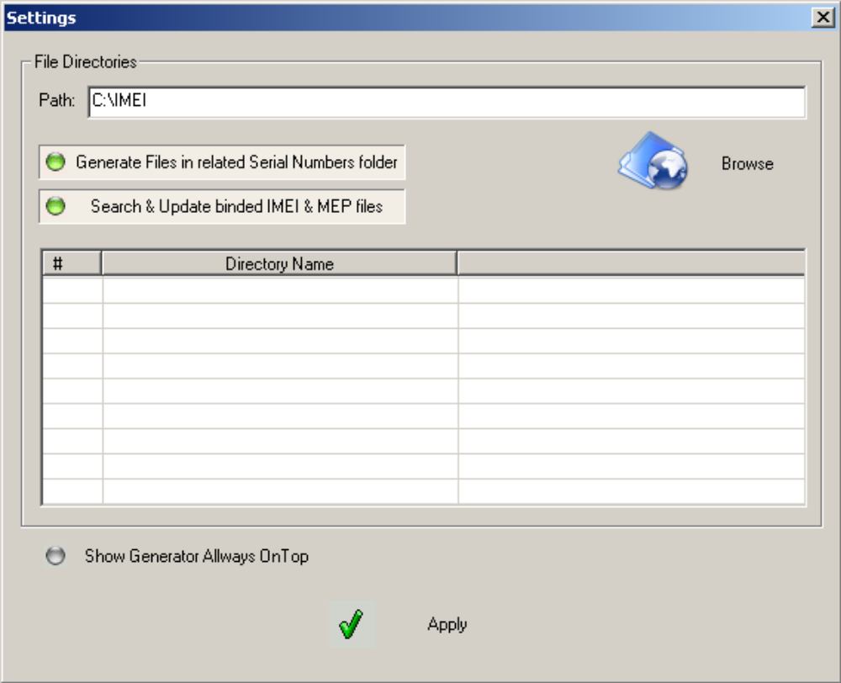
- Click Browse button to change the SN (Serial Number) Directory Path.
Figure 3.4: Settings Dialog Box Browse Button


The Browse for Folder Dialog box is displayed. see figure 3.5
Figure 3.5: Browse for Folder Dialog box
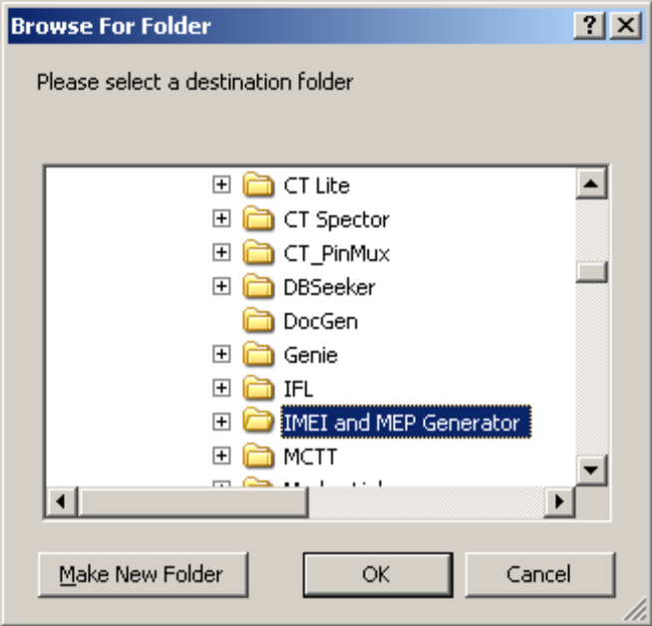

The SN Path Directory is a user defined path that contains directories with the SN number for each
Target. (e.g. If the SN number of the target is 176152 so the path given here will have a directory
called 176152.)

In the Settings dialog box

Figure 3.6: Settings Dialog Box

3. Click the Generate Files in related Serial Numbers folder button to generate IMEI files in the
related Serial Number folder.
4. Click the Search & Update binded IMEI & MEP files button.
The application begins searching for binded IMEI & MEP files.
5. Click the Show Generator Allways OnTop button for the IMEI & MEP Generator window to be
always on top.
6. Click the Apply button to apply settings.
The IMEI file format is as follows:
3GPP IMEI format:
AA-BBBBBB-CCCCCC-EE
Where:
Table 3.2: IMEI File Fields
Term | Description
AA_BBBBBB | TAC(type allocation number)
CCCCCC | SN(Serial Number)
EE | SVN(Software version number)

Example:
35-209900-176148-23
Table 3.3: IMEI File Fields
Term | Description
35-2099-00 | TAC (type allocation number)
176148 | SN (Serial Number)
23 | SVN (software version number)

7. Fill in the following fields:
- I Serial Number (SN)
- Type Allocation Number (TAC)
- Software Version Number(SVN)
- Manufacture Code
- Platform Code
- Platform Number
8. Click the Generate IMEI File button to enable generating the IMEI file.
9. Click the Generate new by index button in order to generate a new Serial Number.
10. Click the Update SN Database button to update the SN database
Click the Open Directory on complete button in order to open the directory where the IMEI file is generated (when process of generating file is completed)
11. Click the Generate IMEI button to generate the IMEI file.

When the IMEI file is generated, it fills in the fields in the IMEI tab.
Figure 3.7: Fields Filled in after Generation of the IMEI File
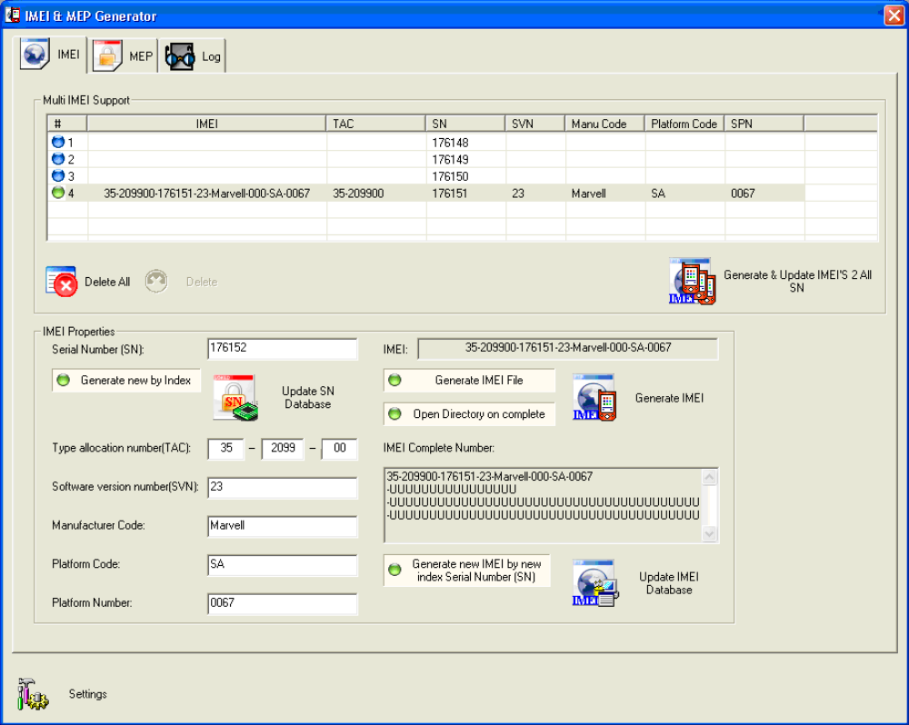

MEP File

To generate the MEP file, click the MEP Tab in the Generator Main Window.
Figure 4.1: MEP Tab
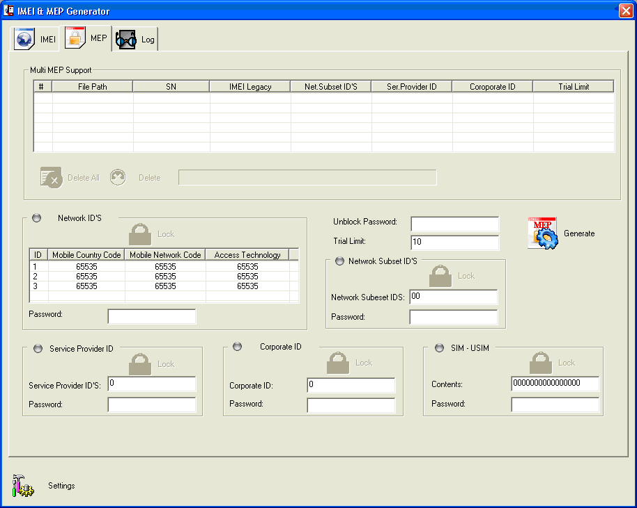

Table 4.1: MEP Tab Fields
Field | Table Fields | Description
Multi Mep Support
 | File Path | Path where the MEP file was created
 | SN | Not in use
 | IMEI Legacy | Not in use
 | Net Subset IDs | MEP file category
 | Set Provider ID | MEP file category
 | Corporate ID | MEP file category
 | Trial Limit | MEP file category
Delete All button |  | Not in use
Delete button |  | Not in use
Delete button |  | Not in use
Network IDs |  | MEP file category
Lock |  | Indicates whether or not the category is Active
 | ID | There are currently 3 networks. This is the Network Index that identifies the network
 | Mobile Country Code | MEP file category parameter
 | Mobile Network Code | MEP file category parameter
 | Access Technology | MEP file category parameter
Password |  | Password for the MEP file category
Unblock Password |  | Password saved in the MEP file in case the phone is blocked
Trial Limit
Generate button |  | Generates the MEP file
Network Subset  IDs |  | MEP file category
Lock |  | Indicates whether or not the category is Active
 | Network Subset IDs | Fill in data for the Network Subset ID category
 | Password | Password for each category of the MEP file
Service Provider  ID |  | MEP file category
Lock |  | Indicates whether or not the category is Active
 | Service Provider IDs | Fill in data for the Service Provider ID category
 | Password | Password for each category of the MEP file
Corporate ID |  | MEP file category
Lock |  | Indicates whether or not the category is Active
 | Corporate ID | Fill in data for the Corporate ID category
 | Password | Password for each category of the MEP file
SIM-USIM |  | MEP file category
Lock |  | Indicates whether or not the category is Active
 | Contents | Fill in data for the SIM-USIM category
 | Password | Password for each category of the MEP file
Settings button |  | Opens the Settings dialog box that includes general  settings such as path of where to create the IMEI files

To generate a MEP file, perform the following:
1. Fill in the Network IDs field
2. Fill in the Mobile Country Code, Mobile Network Code and Access Technology fields.
You can fill in up to three Network IDs.
3. Fill in the Network Subset ID's
4. Fill in the Network Subset IDs field
5. Fill in the Network Subset ID's Password
Service Provider ID
6. Fill in the Service Provider ID field
7. Fill in the Password for the Service Provider ID
Corporate ID
8. Fill in the Corporate ID field
9. Fill in the Password for the Corporate ID
SIM-USIM
10. Fill in the SIM-USIM Contents field
11. Fill in the Password for the SIM-USIM
12. Enable or disable any of these fields by clicking on the gray or green button in the field name
13. Lock or unlock any of the fields by clicking the Lock button.

Figure 4.2: Enabling Disabling Locking or Unlocking Fields
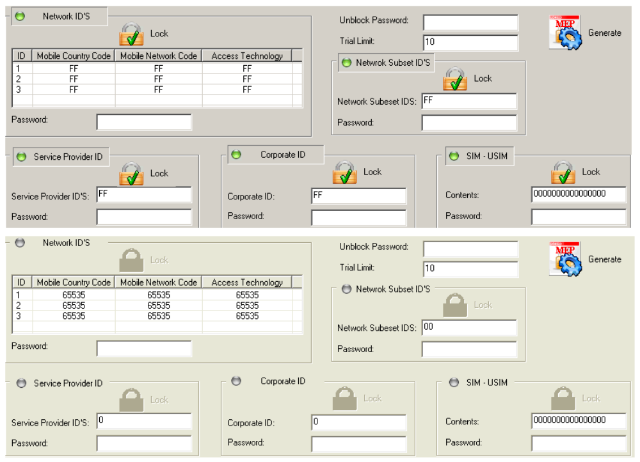

14. Fill in the Unblock Password and Trial Limit fields if applicable.
15. Click the Generate button.

A Browser window is displayed where you can select the path for the generated MEP file.

Figure 4.3: Browser Window
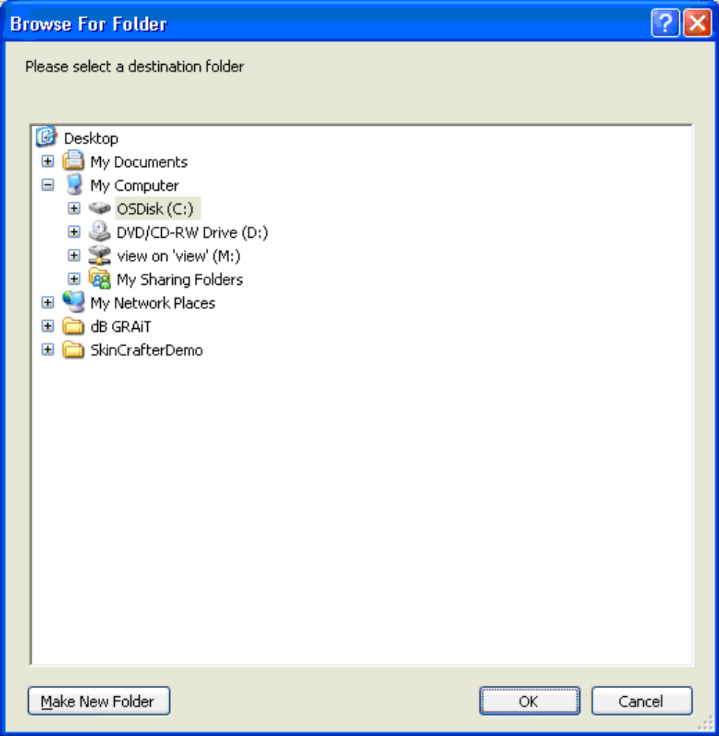
16. Select a path and click OK.
The MEP file is generated and information is added to the Multi MEP Support table.

Figure 4.4: MEP File Added to the Multi MEP Support Table

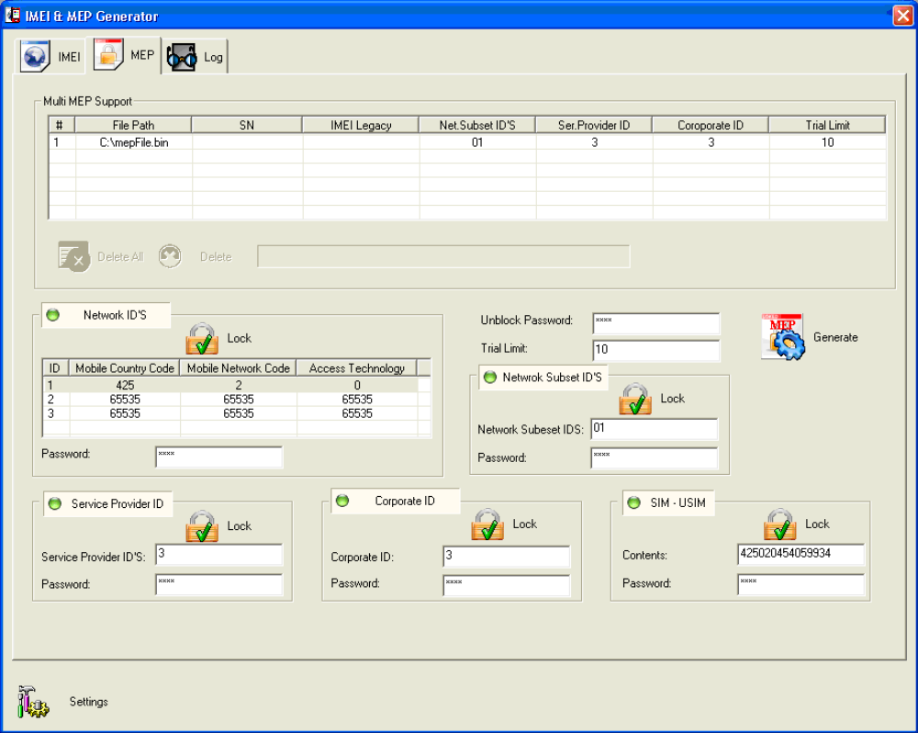

Producing a Log Table

The Log tab displays the log of searching thread when selecting the Search & Update binded IMEI & MEP files button in the Settings window.

Figure 5.1: Selecting the Search & Update binded IMEI & MEP files Button

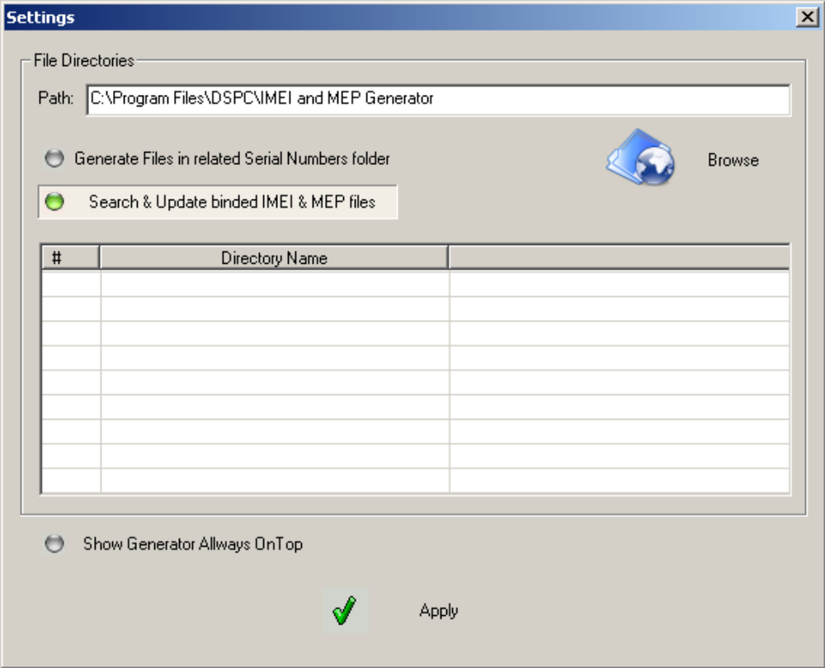
Figure 5.2: Log Tab

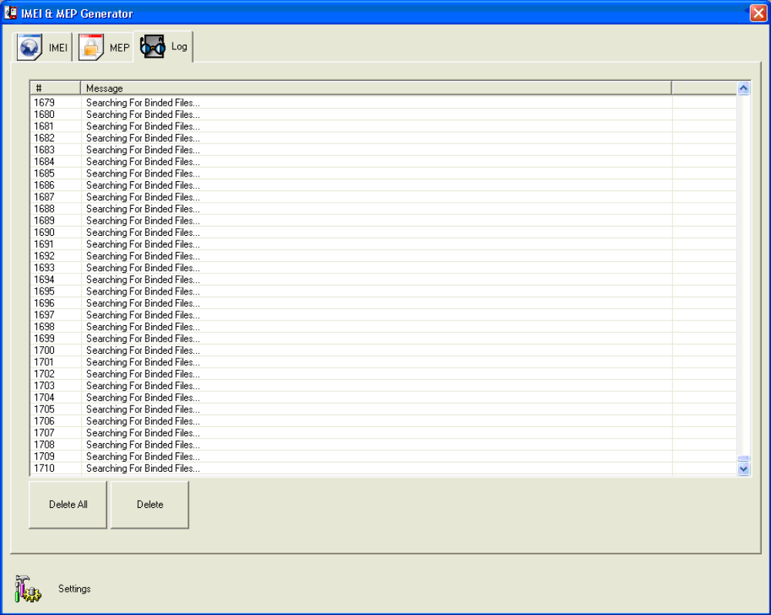

Appendix

Report issues
Please send email to yzhuang@marvell.com and qqzhai@marvell.com with “CTHall Issue Report: …” title.
Or visit webs: http://support.marvell.com.
Or submit an issue at CQ web: http://sh2-cq01.marvell.com/cqweb/login.

Update this document
Please send updated document to yzhuang@marvell.com and qqzhai@marvell.com with “CTHall document update: …” title for merging, and you will receive merged latest version.

Revision History
Table 6.1: Revision History
Document No and Revision | Author | Description | Date
0.1 | Qianqi Zhai | The initial version | 03/04/2010
0.2 | Alex | review | 03/05/2010
0.3 | Qianqi Zhai | review | 05/05/2010

